TOGAF® Template – Architecture Repository
Version 2.0
July 2024
Project XXXX
Client YYYY
Note: This document provides a generic template. It may require tailoring to suit a specific client and project situation.
Document Version History
Version  Number | Version  Date | Revised By | Description | Filename

Contents
1. Purpose of this Document 5
1.1 Output and Input 5
2. Architecture Landscape 6
2.1 Strategic Architectures 6
2.2 Segment Architectures 6
2.3 Capability Architectures 6
3. Reference Library 7
3.1 Overview 7
3.2 Standards Bodies 7
3.3 Product and Service Vendors 7
3.4 Industry Communities or Forums 7
3.5 Standard Templates 7
3.6 Enterprise Best Practice 7
3.7 Reference Architectures 7
3.8 Reference Models 7
3.9 Viewpoint Library 7
3.10 Templates 7
4. Standards Library 8
4.1 Overview 8
4.2 Legal and Regulatory 8
4.3 Industry 8
4.4 Organizational 8
4.5 Standards Classification 8
4.6 Business Standards 8
4.7 Data Standards 8
4.8 Application Standards 8
4.9 Technology Standards 8
5. Governance Repository 9
5.1 Overview 9
5.2 Decision Log 9
5.3 Compliance Assessments 9
5.4 Capability Assessments 9
5.5 Calendar 9
5.6 Project Portfolio 9
5.7 Performance Measurement 9
6. Solutions Landscape 10
7. The Enterprise Repository 11
8. External Repositories 12
8.1 External Reference Models 12
8.2 External Standards 12
8.3 Architecture Board Approvals 12
9. Architecture Capability 13
9.1 Skills Repository 13
9.2 Organization Structure 13
9.3 Architecture Charter 13
Tracking Information
Project Name | Project XXX
Prepared By |  | Document Version No.
Title | Architecture Repository | Document Version Date
Reviewed By |  | Review Date
Distribution List
From | Date | Phone/Email

To | Action* | Due Date | Phone/Email
* Action Types: Approve, Review, Inform, File, Action Required, Attend Meeting, Other (please specify)

Purpose of this Document
The Architecture Repository acts as a holding area for all architecture-related projects within the enterprise. The repository allows projects to manage their deliverables, locate re-usable assets, and publish outputs to stakeholders and other interested parties.

Output and Input
The TOGAF® Content Framework (see Architecture Deliverables) identifies deliverables that are produced as outputs from executing the Architecture Development Method (ADM) cycle and potentially consumed as inputs at other points in the ADM.
This deliverable is produced, updated, and consumed by the ADM Phases:
Deliverable | Output from… | Input to…
Architecture Vision | Preliminary | Preliminary,  A, B, C, D, E, F, G, H,  Requirements Management
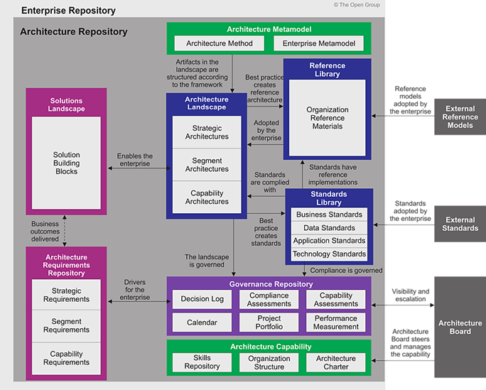

Architecture Landscape

Strategic Architectures

Segment Architectures

Capability Architectures

Reference Library

Overview

Standards Bodies

Product and Service Vendors

Industry Communities or Forums

Standard Templates

Enterprise Best Practice

Reference Architectures

Reference Models

Viewpoint Library

Templates

Standards Library

Overview

Legal and Regulatory

Industry

Organizational

Standards Classification

Business Standards

Data Standards

Application Standards

Technology Standards

Governance Repository

Overview

Decision Log

Compliance Assessments

Capability Assessments

Calendar

Project Portfolio

Performance Measurement

Solutions Landscape

The Enterprise Repository

External Repositories

External Reference Models

External Standards

Architecture Board Approvals

Architecture Capability

Skills Repository

Organization Structure

Architecture Charter

